Project
A project is a temporary endeavor undertaken to create a unique product, service, or result.
Key characteristics
- Temporary – It has a definite beginning and end.
- Unique – It creates something different or a specific outcome.
- Goal-oriented – It is undertaken to achieve defined objectives.
- Progressive – The project becomes clearer and more detailed as it progresses.
- Uses resources – People, money, technology, materials, and time are required.
Example
Developing a new banking mobile application is a project because:
- It starts on a specific date.
- It has a planned completion date.
- A specific team works on it.
- It produces a unique application.
- Once the application is delivered, the project ends.
Project ≠ Operations:
Developing a banking application is a project.
Continuously operating and maintaining the banking application is an operation.
IT Project vs Traditional Project
Area | IT Project | Traditional Project
Main focus | Software, systems, data, technology | Construction, manufacturing, infrastructure
Output | Software/system/digital product | Physical product/structure
Requirements | Can change frequently | Usually more stable
Technology | Major dependency | May have less technology dependency
Customer feedback | Frequent | Often less frequent
Change | High | Comparatively low
Testing | Continuous and extensive | Physical inspection/testing
Example | Mobile banking application | Building a hospital
Example
IT Project:
Develop an online shopping website.
Requirements may change:
"Add online payment." → "Add mobile wallet." → "Add AI chatbot."
Traditional Project:
Build a bridge.
Changing the bridge design after construction has started can be expensive and difficult.
Important point
IT projects generally operate in an environment of high uncertainty and rapid change, so approaches such as Agile can be particularly useful.
Example of an IT Project
Project: Online Banking Application
Objective:
Develop a secure mobile banking application within 9 months.
Major deliverables
- User registration
- Login and authentication
- Account balance
- Fund transfer
- Bill payment
- Transaction history
- Notifications
- Security testing
- Production deployment
Project team
- Project Manager
- Business Analyst
- Developers
- UI/UX Designer
- QA/Testers
- DevOps Engineer
- Security Engineer
- Product Owner
Constraints
- Time: 9 months
- Budget: $500,000
- Scope: Defined banking functionality
- Quality: Security and performance requirements
Project Management
Project management is the application of knowledge, skills, tools, and techniques to project activities to meet project requirements.
In simple words:
Project management means planning, organizing, executing, monitoring, controlling, and closing a project successfully.
The Project Manager coordinates people, budget, schedule, risks, communication, stakeholders, and deliverables throughout the project.

Importance of IT Project Management
IT project management is important because IT projects often involve:
- Complex technology
- Changing requirements
- Multiple stakeholders
- Tight deadlines
- Limited budgets
- Security risks
- Integration challenges
- Quality expectations
Without proper project management
A project may suffer from:
Scope creep → Delays → Cost overruns → Quality problems → Customer dissatisfaction → Project failure
Example
Suppose a company wants to develop an e-commerce application.
Without proper project management:
- Developers don't clearly understand requirements.
- Features keep getting added.
- Testing starts too late.
- Budget increases.
- Release date is missed.
- Customers are unhappy.
With effective project management:
Clear scope → Proper planning → Controlled changes → Risk management → Continuous monitoring → Successful delivery

Project Manager
A Project Manager (PM) is the person responsible for leading and coordinating the project team and managing the project to achieve its objectives.
A PM does not necessarily do all the technical work.
Instead, the PM ensures:
The right people do the right work at the right time within the agreed constraints.
Role of a Project Manager in IT
An IT Project Manager typically performs the following activities:
1. Project Planning
Creates the project plan, schedule, milestones, and approach.
2. Scope Management
Defines what is included and excluded from the project.
3. Schedule Management
Ensures activities are completed on time.
4. Cost Management
Monitors and controls the project budget.
5. Team Management
Builds, coordinates, motivates, and supports the project team.
6. Risk Management
Identifies risks and prepares mitigation strategies.
7. Stakeholder Management
Manages expectations of customers, sponsors, management, users, and other stakeholders.
8. Communication
Ensures the right information reaches the right people at the right time.
9. Quality Management
Ensures project deliverables meet defined quality requirements.
10. Change Management
Evaluates and controls changes to scope, schedule, cost, and requirements.
11. Issue Management
Identifies, tracks, and resolves project issues.
12. Project Closure
Ensures final delivery, documentation, lessons learned, and formal closure.
Skills of an IT Project Manager
An effective IT Project Manager needs a combination of technical, business, leadership, and interpersonal skills.
A. Technical Skills
- Software development lifecycle
- Agile/Scrum
- Testing
- DevOps
- Cloud concepts
- Database concepts
- Cybersecurity awareness
- IT architecture awareness
- Project management tools
The PM doesn't need to be the best developer, but should understand the technology sufficiently to manage the project effectively.
B. Management Skills
- Planning
- Estimation
- Scheduling
- Budget management
- Risk management
- Quality management
- Resource management
- Change management
C. Leadership Skills
- Team building
- Motivation
- Decision making
- Conflict resolution
- Delegation
- Coaching
- Problem solving
D. Communication Skills
- Presentation
- Negotiation
- Active listening
- Stakeholder communication
- Report writing
- Meeting facilitation
E. Business Skills
- Understanding business objectives
- ROI awareness
- Cost-benefit analysis
- Strategic thinking
- Customer orientation
Project Management Frameworks
Three commonly discussed approaches/frameworks are:
- PMBOK
- PRINCE2
- Agile
Note: PMBOK is primarily a body of knowledge/standard and guide, PRINCE2 is a project management method, and Agile is a set of values and principles/approaches rather than one single project-management methodology.
PMBOK
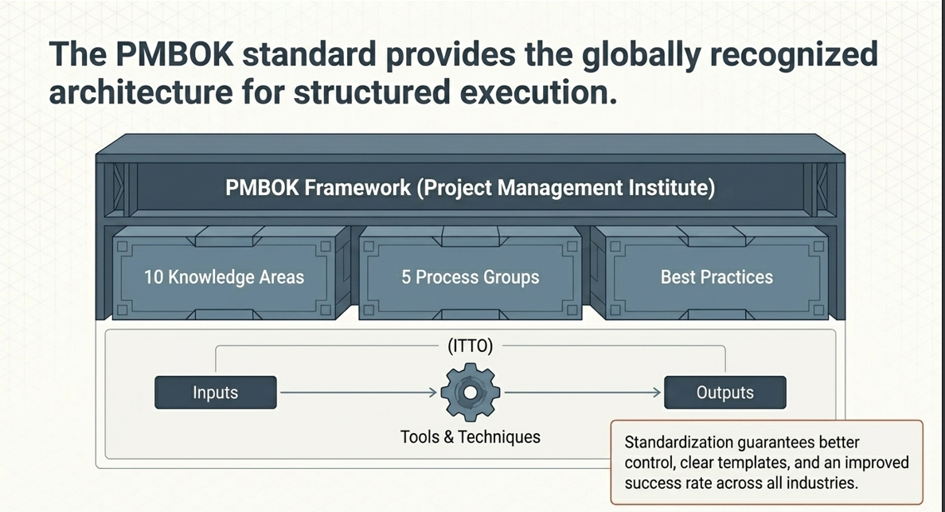
PMBOK = Project Management Body of Knowledge
Published by the Project Management Institute (PMI).
PMBOK provides principles, performance domains, practices, and guidance for managing projects.
Focus
- Value delivery
- Stakeholders
- Planning
- Team
- Project work
- Delivery
- Measurement
- Uncertainty
PMBOK can be applied to:
- IT
- Construction
- Healthcare
- Manufacturing
- Finance
- Government projects
PRINCE2
PRINCE2 = Projects IN Controlled Environments
It is a structured project management method.
Main characteristics
- Clearly defined roles
- Business justification
- Controlled stages
- Defined management products
- Focus on governance
- Controlled changes
- Lessons learned
Example
For a government software project:
Business Case → Project Initiation → Stage 1 → Stage 2 → Stage 3 → Final Delivery
PRINCE2 provides a strong governance and control structure.
Agile
Agile is an approach based on iterative and incremental delivery, continuous feedback, collaboration, and responding to change.
Typical Agile cycle
Plan → Develop → Test → Review → Feedback → Improve
Then repeat.
Example
Instead of waiting 12 months to deliver an entire banking system:
Sprint 1: Login
Sprint 2: Account balance
Sprint 3: Fund transfer
Sprint 4: Bill payment
Sprint 5: Notifications
Customers can provide feedback throughout development.
Popular Agile approaches
- Scrum
- Kanban
- Extreme Programming (XP)
- SAFe
PMBOK vs PRINCE2 vs Agile
Aspect | PMBOK | PRINCE2 | Agile
Nature | Body of knowledge/guidance | Method | Approach
Focus | Principles and practices | Governance and control | Adaptability and delivery
Change | Managed | Controlled | Expected and embraced
Planning | Can be predictive, adaptive, or hybrid | Structured | Iterative
Delivery | Flexible | Stage-based | Incremental
Best suited | Broad range of projects | Structured environments | Dynamic/uncertain projects
Example | IT, construction, healthcare | Government/large structured projects | Software/product development
Ten Knowledge Areas of PMBOK
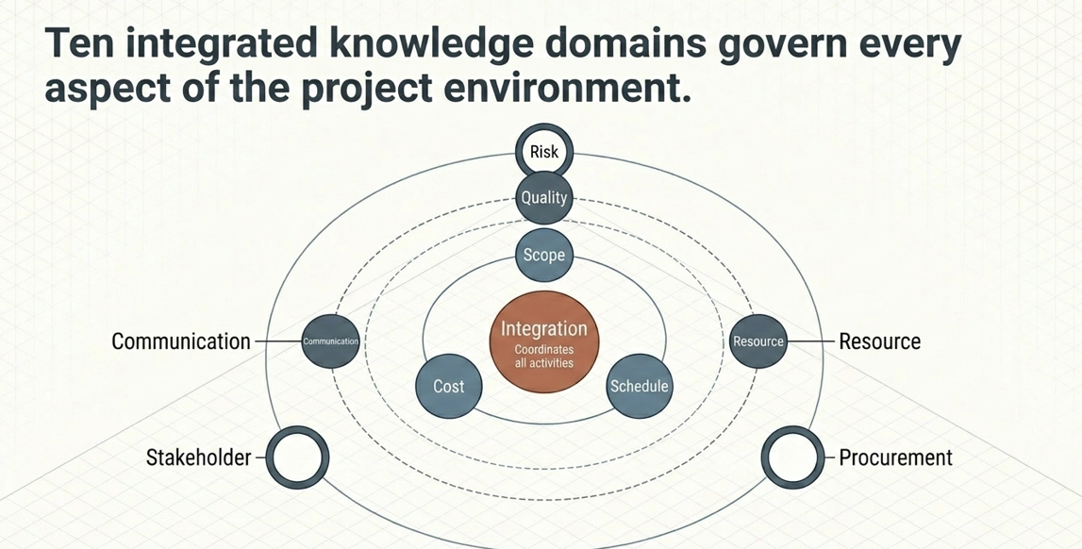
1. Project Integration Management
Coordinates all parts of the project.
Example:
Ensuring development, testing, deployment, budget, schedule, and stakeholders work together.
2. Project Scope Management
Defines what the project will and will not deliver.
Example:
An e-commerce project includes online payment but excludes delivery management.
Main concern: Prevent uncontrolled scope creep.
3. Project Schedule Management
Plans and controls project activities and timelines.
Example:
Activity | Duration
Requirements | 2 weeks
Design | 3 weeks
Development | 8 weeks
Testing | 4 weeks
Deployment | 1 week

4. Project Cost Management
Plans, estimates, budgets, and controls project costs.
Example:
Developer cost = $200K
Infrastructure = $50K
Testing = $50K
Other costs = $50K
Total budget = $350K
5. Project Quality Management
Ensures the project meets required quality standards.
Example:
For a banking application:
- 90%+ test automation
- Zero critical security defects
- Performance requirement met
- Required test coverage achieved
6. Project Resource Management
Manages people and physical resources.
Example:
- 1 Project Manager
- 1 Business Analyst
- 5 Developers
- 3 QA Engineers
- 1 DevOps Engineer
The PM ensures appropriate resources are available when needed.
7. Project Communications Management
Ensures project information is properly generated, distributed, stored, and understood.
Example:
Weekly:
PM → Project status → Management
Daily:
Team → Daily Scrum
Monthly:
PM → Steering Committee
8. Project Risk Management
Identifies, analyzes, and responds to project risks.
Example
Risk: Key developer may leave.
Probability: Medium
Impact: High
Response:
- Cross-train another developer.
- Document critical knowledge.
- Maintain backup resources.
9. Project Procurement Management
Manages purchasing products, services, or resources from external suppliers.
Example:
A company needs a third-party cloud security service.
The project team may need to:
Identify requirement → Prepare procurement → Evaluate vendors → Select vendor → Manage contract
10. Project Stakeholder Management
Identifies stakeholders and manages their engagement.
Example stakeholders
- Customer
- Project sponsor
- End users
- Developers
- QA team
- Management
- Vendors
- Regulatory bodies
The PM needs to understand their interests, expectations, influence, and concerns.
Case Study – Successful IT Project
iPhone – Successful IT Product Case Study
Background
Apple introduced the first iPhone in 2007. It combined a mobile phone, iPod, and internet capabilities into one device.
Project Objective
Create a mobile device that would provide:
- Phone functionality
- Internet access
- Music
- Touch-based user interface
- Simple and attractive user experience
Major Challenges
- Creating a new touch interface
- Integrating hardware and software
- Developing a new mobile operating system
- Keeping the product simple
- Meeting a fixed launch deadline
- Maintaining high quality
Project Management Lessons
1. Clear vision
Apple had a clear product vision.
2. Scope control
The initial iPhone did not try to include every possible feature.
3. Cross-functional team
Hardware, software, design, and business teams worked together.
4. Customer experience
The project focused heavily on usability.
5. Innovation
The project challenged existing assumptions about mobile phones.
Lesson
A successful IT project starts with a clear problem, strong vision, focused scope, and customer value.
Nokia – Failed/Declining Product Strategy Case Study
Background
Nokia was once one of the world's leading mobile-phone companies.
However, Nokia struggled to respond effectively to the rapid transition from traditional mobile phones to smartphones.
What happened?
The market changed significantly:
Traditional phones → Smartphones → App ecosystems → Touch interfaces
Nokia had strong hardware capabilities but faced challenges around software, operating systems, ecosystem development, and strategic execution.
Major Problems
1. Slow response to market change
The smartphone market changed quickly.
2. Software challenges
Nokia's Symbian platform struggled to compete effectively with newer smartphone platforms.
3. Organizational challenges
Decision-making and internal coordination became difficult.
4. Ecosystem disadvantage
Modern smartphones were increasingly about:
Hardware + Operating System + Apps + Developer Ecosystem
5. Strategic decisions
Nokia later partnered with Microsoft and adopted Windows Phone, but the strategy did not restore its former smartphone position.
Project Management Lessons
- Continuously monitor external changes.
- Don't focus only on current success.
- Technology projects need strong strategic alignment.
- User expectations can change rapidly.
- Organizational communication matters.
- A technically good product can still fail commercially.
Lesson
Past success does not guarantee future success. IT projects must continuously adapt to technology and customer changes.
Internet Explorer vs Chrome – Browser Case Study
This is a very good example of competition, innovation, and failure to adapt.
Internet Explorer
Microsoft's Internet Explorer was once the dominant web browser.
For many years, it had a huge market share because it was bundled with Windows.
But competitors such as:
- Firefox
- Chrome
- Safari
introduced new features and competed aggressively.
Problems
Internet Explorer became associated with:
- Slow innovation
- Performance issues
- Security concerns
- Compatibility problems
- Slow release cycles
Microsoft eventually replaced Internet Explorer with Microsoft Edge.
Google Chrome – Successful Browser Case Study
Google launched Chrome in 2008.
Objective
Build a browser that was:
- Fast
- Simple
- Secure
- Stable
- Easy to use
- Suitable for modern web applications
Key Strategy
Chrome focused heavily on:
Performance + Simplicity + Security + Continuous Updates
Project Management Lessons
1. Customer needs
Users wanted faster and simpler browsing.
2. Continuous delivery
Chrome adopted frequent updates rather than waiting years for major releases.
3. Innovation
Chrome introduced strong process isolation and performance improvements.
4. Quality
Security and stability were major priorities.
Lesson
In IT, continuous improvement can be more important than simply delivering a product once.
What These Cases Teach a Project Manager
These examples are excellent for explaining why IT Project Management is different from traditional project management.
Traditional thinking
Plan → Build → Deliver → Finish
Modern IT thinking
Plan → Build → Test → Release → Get feedback → Improve → Repeat
Because technology and customer expectations change quickly, an IT Project Manager must manage not only:
Time + Cost + Scope + Quality
but also:
Innovation + Change + Customer Value + Risk + Adaptability
Successful vs Failed IT Project
Factor | Successful Project | Failed Project
Vision | Clear | Unclear/changes significantly
Requirements | Well managed | Complex/poorly aligned
Stakeholders | Strong engagement | Insufficient alignment
Change | Managed continuously | Difficult to control
Risk | Identified early | Risks may materialize
Communication | Effective | Poor coordination
Technology | Supports business | Technology may not meet needs
User adoption | High | Low/resistance
Governance | Strong | Weak/complex
Outcome | Business value delivered | Objectives not adequately achieved
Portfolio → Program → Project
Portfolio
A portfolio is a collection of projects, programs, and other work that are grouped together to achieve strategic business objectives.
Portfolio = Are we investing in the right work?
Program
A program is a group of related projects managed together to obtain benefits that would be difficult to achieve by managing them separately.
Program = Are we coordinating related projects to achieve greater benefits?
Project
A project is a temporary endeavor undertaken to create a unique product, service, or result.
Project = Are we delivering the specific agreed outcome?
Here:
- Portfolio manages the strategic investment.
- Program manages related projects.
- Project delivers a specific outcome.
IT Example
Imagine a bank wants to become a Digital Bank.
Portfolio: Digital Transformation Portfolio
The bank's strategic goal is:
"Transform the bank into a fully digital banking organization."
The portfolio may contain:
Digital Transformation Portfolio
│
├── Digital Banking Program
│ ├── Mobile Banking Project
│ ├── Internet Banking Project
│ ├── Digital Payment Project
│ └── Digital Onboarding Project
│
├── Data & Analytics Program
│ ├── Data Warehouse Project
│ ├── Customer Analytics Project
│ └── AI Recommendation Project
│
└── Cybersecurity Project
Project Example
Project: Mobile Banking Application
The project has a specific objective:
Develop and launch a mobile banking application within 9 months.
Activities
Requirements
↓
Design
↓
Development
↓
Testing
↓
Security Testing
↓
Deployment
↓
Project Closure
Once the application is delivered and the project objectives are achieved, the project is closed.
Program Example
Suppose the bank wants to provide customers with a complete digital banking experience.
It creates a:
Digital Banking Program
The program contains several related projects:
DIGITAL BANKING PROGRAM
│
┌───────────────┼────────────────┐
│ │ │
▼ ▼ ▼
Mobile Banking Internet Banking Digital Payment
Project Project Project
│ │ │
└───────────────┼────────────────┘
▼
Common Digital Benefits
The projects are related because they all contribute to the same digital banking objective.
The Program Manager coordinates things such as:
- Shared resources
- Dependencies
- Common technology
- Risks
- Integration
- Benefits
- Stakeholders
Portfolio Example
At an even higher level, the bank may have many strategic initiatives:
BANK IT PORTFOLIO
│
┌─────────────────┼─────────────────┐
▼ ▼ ▼
Digital Banking Data & AI Cybersecurity
Program Program Program
│ │ │
Projects Projects Projects
The Portfolio Manager / senior leadership decides:
- Which initiatives should receive funding?
- Which projects should have higher priority?
- Which projects should be stopped?
- Where should resources be allocated?
- Which initiatives provide the greatest strategic value?
Portfolio vs Program vs Project
Aspect | Portfolio | Program | Project
Main focus | Strategy | Benefits | Deliverable
Contains | Projects, programs, other work | Related projects | Activities/tasks
Objective | Strategic objectives | Common benefits | Specific outcome
Time | May be ongoing | May be long-term | Temporary
Change | Portfolio-level strategic changes | Coordinated changes | Controlled project changes
Success | Strategic value | Benefits realization | Scope, schedule, cost, quality & objectives
Example | Digital Transformation Portfolio | Digital Banking Program | Mobile Banking Project

Goals and Objectives
Goal
In project management, a goal is a broad desired result or direction that the organization, project, or team wants to achieve.
A goal provides overall direction and purpose, but it may not be sufficiently detailed to measure project performance by itself.
IT Company Example
Goal: Improve the quality of software products.
This tells us what we want to achieve, but not exactly how much improvement is expected or by when.
Objective
A project objective is a specific result that the project intends to achieve. Good project objectives should be clear, measurable, realistic, and aligned with organizational and stakeholder needs.
Objectives help translate a broad goal into measurable project outcomes.
Example
Goal:
Improve software quality.
Project Objectives:
- Reduce production defect leakage.
- Increase automated test coverage.
- Improve compliance with code-review practices.
- Reduce the time required to resolve critical defects.
Goal vs Objective
Goal | Objective
Broad desired outcome | Specific result
Provides direction | Defines what must be achieved
Usually less detailed | More precise and measurable
May contain several objectives | Supports achievement of a goal
Strategic in nature | Can be project-specific
Simple example
Goal: Improve customer experience.
Objective: Reduce the average response time for customer support issues from 8 hours to 4 hours by December 2026.
SMART Objectives
SMART is a useful technique for developing clear and measurable objectives.
SMART means:
S – Specific
Clearly state what needs to be achieved.
M – Measurable
Define how achievement will be measured.
A – Achievable
The target should be realistically attainable with available resources and constraints.
R – Relevant
The objective should support the project and organizational/business needs.
T – Time-bound
Specify when the objective must be achieved.
SMART IT Project Objective
Non-SMART
Improve software quality.
The statement is too broad.
We don't know:
- How much improvement?
- Which quality measure?
- By when?
- How will success be measured?
SMART
Reduce production defect leakage by 25% by December 31, 2026, through increased test automation, improved code reviews, and defect-prevention activities.
SMART Analysis
SMART | Application
Specific | Reduce production defect leakage
Measurable | 25% reduction
Achievable | Through defined improvement activities
Relevant | Supports software quality
Time-bound | December 31, 2026
Examples of SMART Objectives in IT Projects
Quality
Reduce critical production defects by 30% by the end of Q4 2026.
Testing
Increase automated regression test coverage from 50% to 75% by December 2026.
Schedule
Complete at least 95% of planned project milestones within the approved schedule by the end of 2026.
Performance
Reduce average API response time from 2 seconds to less than 1 second by September 30, 2026.
Security
Reduce critical security vulnerabilities identified after release by 50% by December 2026 through automated security testing and mandatory remediation.
Training
Train 90% of project team members on the approved AI-assisted development tools by October 31, 2026, with each participant completing one practical exercise.
Examples of Non-SMART Objectives
❌ Improve software quality.
Problem: No measurement or deadline.
❌ Increase automation.
Problem: No baseline or target.
❌ Reduce defects.
Problem: No percentage or timeframe.
❌ Deliver the project faster.
Problem: "Faster" is not measurable.
❌ Improve customer satisfaction.
Problem: No defined customer satisfaction measure or target.
❌ Train employees in AI.
Problem: No number of employees, completion criteria, or deadline.
Converting Non-SMART to SMART
Non-SMART | SMART
Improve quality | Reduce production defect leakage by 25% by Dec 2026
Increase automation | Increase regression automation from 50% to 75% by Dec 2026
Reduce defects | Reduce critical production defects by 30% by Q4 2026
Deliver faster | Improve schedule adherence to ≥95% by Dec 2026
Improve customer satisfaction | Increase customer satisfaction from 82% to 90% by Dec 2026
Train employees | Train 90% of project team members on AI-assisted development by Oct 2026

IT Project Management Lifecycle
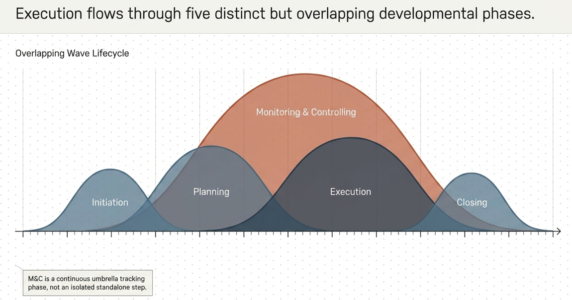
A simple way to understand an IT project is:
1. Initiation
↓
2. Planning
↓
3. Execution
↓
4. Monitoring & Controlling
↓
5. Closing
Example: Mobile Banking Project
Initiation:
Why do we need the application?
↓
Planning:
What will we build? Who will build it? How much will it cost? When will it finish?
↓
Execution:
Develop and test the application.
↓
Monitoring & Controlling:
Track scope, schedule, cost, quality, risks, and issues.
↓
Closing:
Deploy, obtain acceptance, document lessons learned, and formally close the project.
Key Takeaway
A good IT Project Manager must continuously balance:
Scope + Time + Cost + Quality + Resources + Risk + Stakeholders + Business Value
The ultimate objective is not simply to finish the project.
A successful IT project delivers the intended business value and satisfies the needs of its stakeholders.
Project Constraints and Triple Constraint
According to the traditional PMBOK approach, project constraints are factors that limit the options available to the project team and influence how the project can be planned and executed.
A project manager must balance these constraints because changing one constraint can affect the others.
Common Project Constraints
Traditionally, the three major project constraints are:
- Scope
- Time
- Cost
However, projects are also affected by other constraints such as:
- Quality
- Resources
- Risk
- Stakeholder expectations
- Technology
- Regulatory requirements
Project Triple Constraint
The Triple Constraint is commonly represented as:
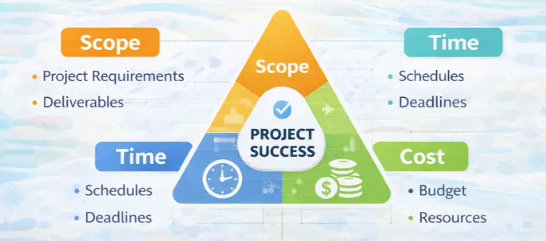
The basic idea is:
You cannot change one major constraint without potentially affecting the others.
Scope
What is Scope?
Scope defines the work that must be performed and the deliverables that must be produced to achieve the project's objectives.
It answers:
What are we going to deliver?
Example
A project is to develop a mobile banking application.
Scope includes:
- Login
- Account balance
- Fund transfer
- Bill payment
- Transaction history
But it does not include:
- Stock trading
- Insurance
- Cryptocurrency
Those excluded features are outside the agreed project scope.
Time
Time represents the duration or schedule required to complete the project.
It answers:
When must the project be completed?
Example
The mobile banking application must be completed within:
9 months
The project has milestones such as:
Requirements → 1 month
Design → 1 month
Development → 4 months
Testing → 2 months
Deployment → 1 month
──────────
9 months
Cost
Cost represents the budget and financial resources required to complete the project.
It answers:
How much will it cost?
Example
The project budget is:
$500,000
It may include:
- Employee salaries
- Infrastructure
- Software licenses
- Cloud services
- Testing tools
- Consultants
- Training
Example of Triple Constraint
Imagine a company wants to develop an e-commerce application.
Original project
Scope:
20 features
Time:
6 months
Cost:
$300,000
Quality:
Agreed quality standards
SCOPE
20 features
/\
/ \
/ \
/ \
/ \
▼ ▼
TIME COST
6 months $300K
Now the customer says:
"We need 10 additional features."
The scope has increased.
What can happen?
Option 1 – Increase Time
20 features → 30 features
Time: 6 → 8 months
Cost may remain approximately the same.
Option 2 – Increase Cost
Hire additional developers.
Time: Remains 6 months
Cost: $300K → $400K
Option 3 – Reduce Scope Elsewhere
Add the 10 new features but remove lower-priority features.
Time: 6 months
Cost: $300K
But the original scope has changed.
Option 4 – Reduce Quality
Try to complete everything within 6 months and $300K by reducing testing.
This is generally not a good project-management decision, because it can create defects, security problems, and customer dissatisfaction.
Real-Life Example: Construction Project
Suppose a company wants to build a hospital.
Original baseline
Constraint | Target
Scope | 200-bed hospital
Time | 24 months
Cost | $50 million
Quality | Required building standards
Now the sponsor says:
"Make it a 300-bed hospital but finish at the same time."
Impact
Scope ↑
Therefore, the project may require:
Cost ↑
and/or
Time ↑
SCOPE
200 → 300 beds
/\
/ \
/ \
▼ ▼
TIME COST
↑ ↑
24 months $50M+
The Project Manager must negotiate and determine what can realistically change.
Expanded Project Constraints
Modern project management recognizes that projects are influenced by more than just scope, time, and cost.
A commonly used expanded model includes:
SCOPE
│
▼
┌───────┐
TIME ───►│PROJECT│◄─── COST
└───────┘
│
┌─────────────┼─────────────┐
▼ ▼ ▼
QUALITY RESOURCES RISK
│
▼
STAKEHOLDERS
Important constraints
Scope – What will be delivered?
Schedule – When will it be delivered?
Cost – How much can we spend?
Quality – How well must it perform?
Resources – Who and what are available?
Risk – What uncertainties can affect the project?
Stakeholders – What expectations and requirements must be satisfied?
Triple Constraint Example in IT
Project: Hospital Management System
The customer initially requests:
- Patient registration
- Appointment management
- Billing
- Pharmacy
- Reports
Baseline
Scope: 5 major modules
Time: 8 months
Cost: $400,000
After 4 months, the customer requests:
"Add an AI diagnosis assistant."
This is a scope change.
The Project Manager should evaluate its impact on:
- Scope
- Schedule
- Cost
- Resources
- Risk
- Quality
- Security
- Compliance
The PM should not simply tell the development team to add it.
Instead:
Change request → Impact analysis → Stakeholder decision → Update baselines/plans → Implement approved change
The Most Important Concept
The Triple Constraint teaches us that project constraints are interdependent.
Scope increases
➡️ Usually requires more time and/or cost
Time decreases
➡️ May require more resources/cost or reduced scope
Cost decreases
➡️ May require reduced scope, extended time, or different resources
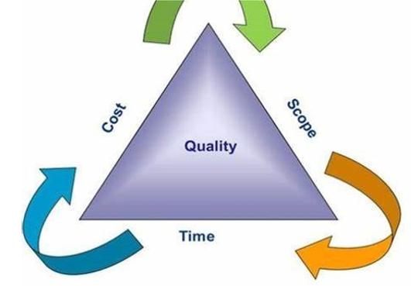
1. Initiation Phase
What is it?
The Initiation Phase formally starts the project. The organization determines why the project is needed, whether it is feasible, what the high-level objectives are, and who the stakeholders are.
Main purpose
- Identify the business need
- Define the project at a high level
- Identify key stakeholders
- Obtain authorization to start the project
- Appoint/identify the Project Manager
Key PMBOK Processes
- Develop Project Charter
- Identify Stakeholders
Inputs → Tools & Techniques → Outputs
Process | Inputs | Tools & Techniques | Outputs
Develop Project Charter | Business documents, agreements, EEFs, OPAs | Expert judgment, data gathering, interpersonal/team skills, meetings | Project Charter
Identify Stakeholders | Project Charter, business documents, project management plan, project documents, agreements, EEFs, OPAs | Expert judgment, data gathering, data analysis, decision making, data representation, meetings | Stakeholder Register
Important Inputs
Business Case
- Explains why the project should be undertaken.
- Contains benefits, costs, risks, alternatives, and justification.
Project Statement of Work (SOW)
- Describes the product, service, or result that the project will deliver.
Enterprise Environmental Factors (EEFs)
- Conditions outside the project team's control.
- Example: government regulations, organizational culture, market conditions.
Organizational Process Assets (OPAs)
- Existing organizational knowledge and resources.
- Example: templates, policies, procedures, historical project data.
Main Outputs
Project Charter
Authorizes the project and gives the Project Manager authority to use organizational resources.
It generally contains:
- Project purpose
- Objectives
- High-level scope
- Major deliverables
- High-level requirements
- Key stakeholders
- Major risks
- Assumptions
- Constraints
- Milestones
- Budget summary
- Project Manager's authority
Stakeholder Register
Records:
- Who the stakeholders are
- Their roles
- Interests
- Influence
- Expectations
- Impact on the project
Simple Example
Project: Develop an Online Hospital Appointment System
Initiation determines:
"The hospital needs an online appointment system to reduce patient waiting time and improve appointment management."
The project charter authorizes the project, and the stakeholder register identifies hospital management, doctors, patients, IT team, QA team, and government/regulatory bodies.

2. Planning Phase
What is it?
Planning determines exactly how the project will be executed, monitored, controlled, and completed.
This is generally the most detailed phase because the project team develops the project management plan and supporting plans.
Main purpose
- Define detailed scope
- Create WBS
- Estimate resources, time, and cost
- Develop schedule
- Develop budget
- Identify and plan responses to risks
- Plan quality
- Plan communication
- Plan stakeholder engagement
- Plan procurement
- Establish baselines
Major PMBOK Planning Processes
Examples include:
- Develop Project Management Plan
- Plan Scope Management
- Collect Requirements
- Define Scope
- Create WBS
- Plan Schedule Management
- Define Activities
- Sequence Activities
- Estimate Activity Durations
- Develop Schedule
- Plan Cost Management
- Estimate Costs
- Determine Budget
- Plan Quality Management
- Plan Resource Management
- Plan Communications Management
- Plan Risk Management
- Identify Risks
- Perform Qualitative Risk Analysis
- Perform Quantitative Risk Analysis
- Plan Risk Responses
- Plan Procurement Management
- Plan Stakeholder Engagement
Inputs → Tools & Techniques → Outputs
Because Planning contains many processes, its ITTOs are extensive. At a high level:
Planning Area | Typical Inputs | Tools & Techniques | Major Outputs
Scope | Charter, requirements, stakeholder information | Expert judgment, product analysis, decomposition | Scope Management Plan, Requirements, Scope Statement, WBS
Schedule | Scope, activities, resources | Critical Path Method, PERT, network analysis | Schedule Management Plan, Schedule, Schedule Baseline
Cost | Scope, schedule, resources | Analogous/parametric estimation, bottom-up estimation | Cost Estimates, Budget, Cost Baseline
Quality | Requirements, scope, organizational policies | Cost-benefit analysis, quality planning | Quality Management Plan
Resources | Scope, schedule, requirements | Organizational charts, RACI, expert judgment | Resource Management Plan
Risk | Scope, assumptions, stakeholder information | Risk identification, qualitative/quantitative analysis | Risk Register, Risk Responses
Communication | Stakeholder information | Communication requirements analysis | Communications Management Plan
Procurement | Scope, requirements, market conditions | Make-or-buy analysis, market research | Procurement Management Plan
Stakeholders | Stakeholder register | Engagement assessment | Stakeholder Engagement Plan
Most Important Output: Project Management Plan
The Project Management Plan integrates all subsidiary plans and baselines.
It may include:
- Scope Management Plan
- Schedule Management Plan
- Cost Management Plan
- Quality Management Plan
- Resource Management Plan
- Communications Management Plan
- Risk Management Plan
- Procurement Management Plan
- Stakeholder Engagement Plan
- Requirements Management Plan
- Change Management Plan
- Configuration Management Plan
And baselines such as:
Scope Baseline + Schedule Baseline + Cost Baseline
Together, these form the Performance Measurement Baseline.

WBS – Important Planning Output
WBS = Work Breakdown Structure
It breaks the project scope into smaller, manageable components.
Example:
Online Hospital Appointment System
│
├── 1. Requirements
│ ├── 1.1 Patient Requirements
│ └── 1.2 Doctor Requirements
│
├── 2. Design
│ ├── 2.1 UI Design
│ └── 2.2 Database Design
│
├── 3. Development
│ ├── 3.1 Patient Module
│ ├── 3.2 Doctor Module
│ └── 3.3 Admin Module
│
├── 4. Testing
│ ├── 4.1 Functional Testing
│ └── 4.2 Performance Testing
│
└── 5. Deployment
The lowest level of the WBS contains work packages.

3. Execution Phase
What is it?
Execution is where the project team performs the work defined in the project management plan and creates the project's deliverables.
In simple terms:
Planning says what and how; Execution actually does it.
Main purpose
- Perform project work
- Create deliverables
- Manage project team
- Manage resources
- Perform quality assurance
- Communicate with stakeholders
- Implement risk responses
- Conduct procurements
- Manage knowledge
Key PMBOK Processes
Examples:
- Direct and Manage Project Work
- Manage Project Knowledge
- Manage Quality
- Acquire Resources
- Develop Team
- Manage Team
- Manage Communications
- Implement Risk Responses
- Conduct Procurements
- Manage Stakeholder Engagement
Inputs → Tools & Techniques → Outputs
Process Area | Inputs | Tools & Techniques | Outputs
Direct & Manage Work | Project Management Plan, Project Documents | Expert judgment, PMIS, meetings | Deliverables, Work Performance Data
Manage Quality | Quality Management Plan, Quality Metrics | Quality audits, problem solving, quality improvement | Quality Reports, Test & Evaluation Documents
Acquire Resources | Resource Management Plan | Negotiation, decision making | Physical/Team Resources
Develop Team | Resource Management Plan | Team building, training, recognition | Team Performance Assessments
Manage Team | Team performance data | Conflict management, decision making | Change Requests, Project Management Plan Updates
Manage Communications | Communications Plan | Communication methods, PMIS | Project Communications
Implement Risk Responses | Risk Register, Risk Plan | Expert judgment, risk response strategies | Change Requests, Issue Updates
Conduct Procurements | Procurement Plan, Bid Documents | Bidder conferences, proposal evaluation, negotiation | Selected Sellers, Agreements
Manage Stakeholder Engagement | Stakeholder Engagement Plan | Communication, interpersonal skills | Change Requests, Project Management Plan Updates
Major Outputs
Deliverables
- The actual products/services/results produced by the project.
Work Performance Data
- Raw observations and measurements.
- Example:
  - 15 tasks completed
  - 3 defects found
  - 80 hours spent
Change Requests
- Requests to modify scope, schedule, cost, quality, etc.
Example
For the hospital appointment system:
During execution:
- Developers develop the application.
- QA tests it.
- Database team creates databases.
- UI team develops interfaces.
- Project manager coordinates the team.
- Risks are addressed.
- Stakeholders receive project updates.

4. Monitoring & Controlling Phase
What is it?
Monitoring and Controlling happens throughout the project, alongside Execution.
It answers:
"Are we doing what we planned, and if not, what corrective action should we take?"
This phase is not performed only after execution.
Main purpose
- Monitor project performance
- Compare actual performance with baselines
- Identify deviations
- Control scope
- Control schedule
- Control cost
- Control quality
- Monitor risks
- Control changes
- Monitor stakeholder engagement
- Take corrective/preventive action
Key PMBOK Processes
Examples:
- Monitor and Control Project Work
- Perform Integrated Change Control
- Validate Scope
- Control Scope
- Control Schedule
- Control Costs
- Control Quality
- Monitor Communications
- Monitor Risks
- Control Procurements
- Monitor Stakeholder Engagement
Inputs → Tools & Techniques → Outputs
Process | Inputs | Tools & Techniques | Outputs
Monitor & Control Work | Project Management Plan, Project Documents, Work Performance Data | Expert judgment, data analysis, decision making | Work Performance Reports, Change Requests
Integrated Change Control | Project Management Plan, Change Requests, Work Performance Reports | Change control tools, decision making, meetings | Approved/Rejected Change Requests, Plan Updates
Validate Scope | Scope Baseline, Requirements, Verified Deliverables | Inspection, decision making | Accepted Deliverables, Change Requests
Control Scope | Scope Baseline, Requirements | Variance analysis, trend analysis | Work Performance Information, Change Requests
Control Schedule | Schedule Baseline, Project Schedule | Critical Path Method, trend analysis, EVM | Schedule Forecasts, Change Requests
Control Costs | Cost Baseline, Cost Data | Earned Value Management, variance analysis | Cost Forecasts, Change Requests
Control Quality | Quality Metrics, Test Results | Inspection, testing, data analysis | Verified Deliverables, Quality Reports
Monitor Risks | Risk Register, Issue Log | Risk reassessment, audits, data analysis | Risk Updates, Change Requests
Key Concept: Performance Comparison
The project manager compares:
Planned vs Actual
For example:
Metric | Planned | Actual | Status
Schedule | 60 days | 68 days | ⚠️ Delayed
Budget | $100,000 | $108,000 | ⚠️ Over budget
Defects | <20 | 12 | ✅ Good
Scope | 100% | 100% | ✅ Good
The Project Manager then determines whether corrective or preventive action is required.

5. Closing Phase
What is it?
Closing formally completes the project or a project phase.
The project is not considered complete simply because the product has been developed.
The project must be formally closed and accepted.
Main purpose
- Obtain formal acceptance
- Complete all project work
- Close contracts
- Archive documents
- Release resources
- Capture lessons learned
- Transition the product/service
- Formally close the project
Key PMBOK Process
Close Project or Phase
Inputs → Tools & Techniques → Outputs
Process | Inputs | Tools & Techniques | Outputs
Close Project or Phase | Project Charter, Project Management Plan, Project Documents, Accepted Deliverables, Business Documents, Agreements, Procurement Documents | Expert judgment, data analysis, meetings | Final Product/Service/Result Transition, Final Report, Organizational Process Asset Updates
Major Outputs
1. Final Product/Service/Result Transition
- Product is handed over to operations/customer.
2. Final Report
Contains overall project performance such as:
- Scope achieved
- Schedule performance
- Cost performance
- Quality performance
- Major risks/issues
- Lessons learned
3. Lessons Learned
Documents:
- What went well?
- What went wrong?
- What should be repeated?
- What should be avoided?
4. Organizational Process Asset Updates
The organization updates its knowledge repository with:
- Lessons learned
- Templates
- Historical information
- Project records
Example
For the hospital appointment system:
- Hospital formally accepts the system.
- System is transferred to the operations/support team.
- Contracts are closed.
- Project documents are archived.
- Project team members are released.
- Final report is prepared.
- Lessons learned are documented.

Complete 5-Phase Flow
PROJECT
│
▼
┌─────────────────────┐
│ 1. INITIATION │
│ Why do we do it? │
└──────────┬──────────┘
│
▼
┌─────────────────────┐
│ 2. PLANNING │
│ How will we do it? │
└──────────┬──────────┘
│
▼
┌─────────────────────┐
│ 3. EXECUTION │
│ Do the work │
└──────────┬──────────┘
│
▼
┌──────────────────────────┐
│ 4. MONITOR & CONTROL │
│ Are we on track? │
└──────────┬───────────────┘
│
Corrective/
Preventive Action
│
└──────► Execution
│
▼
┌─────────────────────┐
│ 5. CLOSING │
│ Formally finish │
└─────────────────────┘
Quick ITTO Summary
Phase | Key Inputs | Key Tools & Techniques | Key Outputs
Initiation | SOW, Business Case, Agreements, EEFs, OPAs | Expert Judgment, Data Gathering, Meetings | Project Charter, Stakeholder Register
Planning | Charter, Requirements, Stakeholder Register, EEFs, OPAs | Expert Judgment, Decomposition, Estimation, CPM, PERT, Risk Analysis | Project Management Plan, WBS, Schedule, Budget, Risk Register, Baselines
Execution | Project Management Plan, Project Documents | Expert Judgment, PMIS, Team Skills, Meetings | Deliverables, Work Performance Data, Change Requests, Project Updates
Monitoring & Controlling | Plan, Baselines, Work Performance Data, Project Documents | Variance Analysis, Trend Analysis, EVM, Inspection, Audits, CPM | Work Performance Information, Reports, Forecasts, Change Requests, Approved Changes
Closing | Project Plan, Accepted Deliverables, Project Documents, Agreements | Expert Judgment, Data Analysis, Meetings | Final Product/Service, Final Report, Lessons Learned, OPA Updates
Easy way to remember
Initiation → PLANNING → EXECUTION → MONITOR & CONTROL → CLOSING
Initiation: Why?
Planning: What, how, when, who, and how much?
Execution: Do it.
Monitoring & Controlling: Check it and correct it.
Closing: Accept it, hand it over, and formally finish it.

